Data Quality Curriculum (DQC)
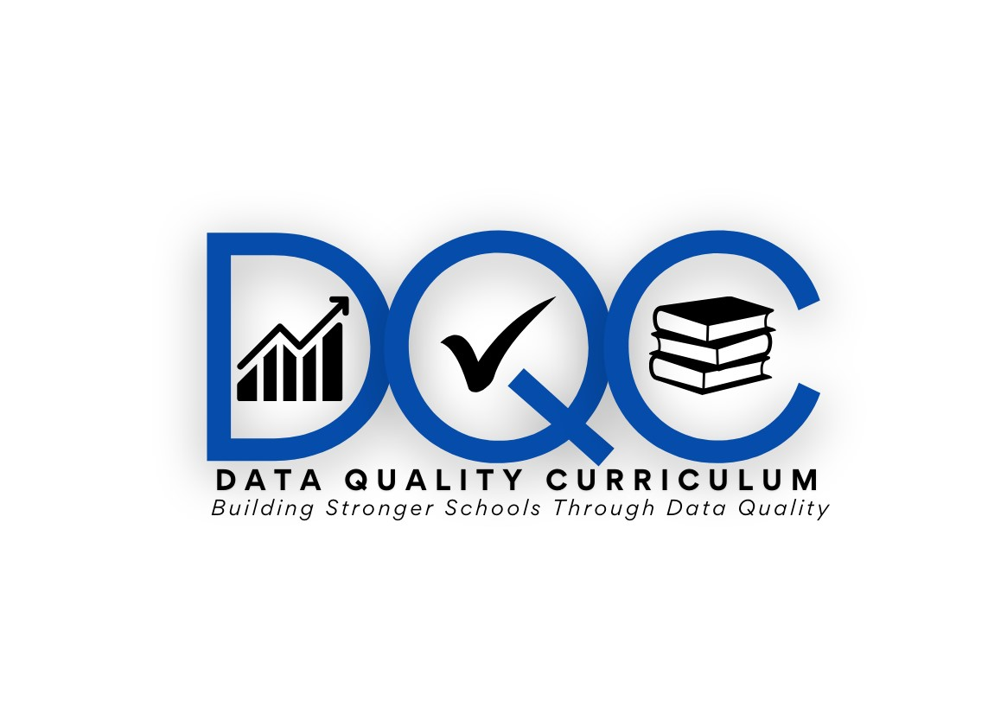
Overview and Course Catalog

Table of Contents

Data Quality Curriculum Overview 4
Curriculum Outline 4
DQC Progression Diagram 5
Curriculum Prerequisites 5
New PIMS Administrators 5
Entry Level PIMS Administrators 6
Experienced PIMS Administrators 6
Delete Utility Specialty Module 7
Modules 7
ACT 45/ ACT 48 Credits 7
Data Quality Curriculum Course Catalog 7
General Requirements 7
Certificate of Completion 7
Data Quality Curriculum Tracks 8
New PIMS Administrator Track 8
Entry Level PIMS Administrator Track 8
PIMS Reporting for Foundational Collections Track 8
Special Education Track 8
LEA Administrator Track 9
Building Level Administrator Track 9
Data Quality Curriculum Modules 10
Beginner Level Modules 10
Act 13 Educator Effectiveness/PVAAS 10
Data Governance 10
Data Literacy 10
Data Quality Engine 11
EdNA Basics 11
EdNA Reports 11
EL Reporting 12
Excel for PIMS 12
Internal Snapshots 12
PAsecureID 12
PIMS Upload Simulation 13
Advanced Level Modules 13
Accountability 13
Assessment 13
Career and Technology Education 14
Career Standards Benchmark 14
Charter School Updates 14
Child Accounting 15
Course/Appropriately Certified 15
FRCPP- Administrator Changes 15
FRCPP- School Reconfiguration Changes 16
Future Ready Overview 16
Non-CTE ICN/WBL (Industry Credential) 17
School Services- Ward of State 17
Experienced PIMS Administrator Exam 17
Delete Utility Specialty Module 18

Data Quality Curriculum Overview

Welcome to the Data Quality Curriculum (DQC)!
The DQC is a tool for local education agencies (LEAs) to increase the quality of data submitted to the Pennsylvania Department of Education (PDE), thereby reducing costly data errors and staff time. The DQC is the only PDE-offered and approved training program for the Pennsylvania Information Management System (PIMS) data submissions.
The goal is to educate participants, not just on the data components associated with PIMS reporting, but also to help familiarize them with the content and navigation of the resources that are already available publicly. This is a voluntary program, inclusive of self-paced activities, assessments, and tutorials. For more information on the DQC Tracks and Modules please refer to the individual track or module course catalog section of this document.
Additional information and a registration link are provided on the Data Quality Curriculum website.

Curriculum Outline
*Note: Individuals that have previously completed DQC content to attain one of the statuses outlined (New, Entry Level or Experienced) maintain that level and can proceed through additional levels, based on that status.
The DQC is designed to prepare and aid PIMS Administrators, and other data staff to be more successful in their role. With that in mind, the format of the curriculum is intended to address knowledge needs at different levels of experience. Our goal is to help individuals continue to grow and learn as their understanding of PIMS data progresses.
Please note that individuals that are new to the Data Quality Curriculum are required to start at the beginning regardless of their level of experience within the PIMS field. The intent is to familiarize you with the Data Quality Curriculum format and to hopefully provide information along the way that was overlooked or reinforce knowledge that may have been forgotten.
For the purpose of providing the most balanced and progressive instruction, the Data Quality Curriculum is modeled to follow an expected knowledge progression. Individuals registering for courses through the DQC can only attain a higher level by demonstrating an understanding of the content provided at each prior step.
The curriculum Tracks are designed to reflect the expected knowledge of each level of a PIMS Administrator. Each stage of PIMS Administrator status (New, Entry Level, or Experienced) should be demonstrated by successful completion and progression through the DQC. For detailed requirements of each stage, review the prerequisite information provided in this guide.
An outline of the expected progressions through the DQC is provided in the diagram that follows:

DQC Progression Diagram

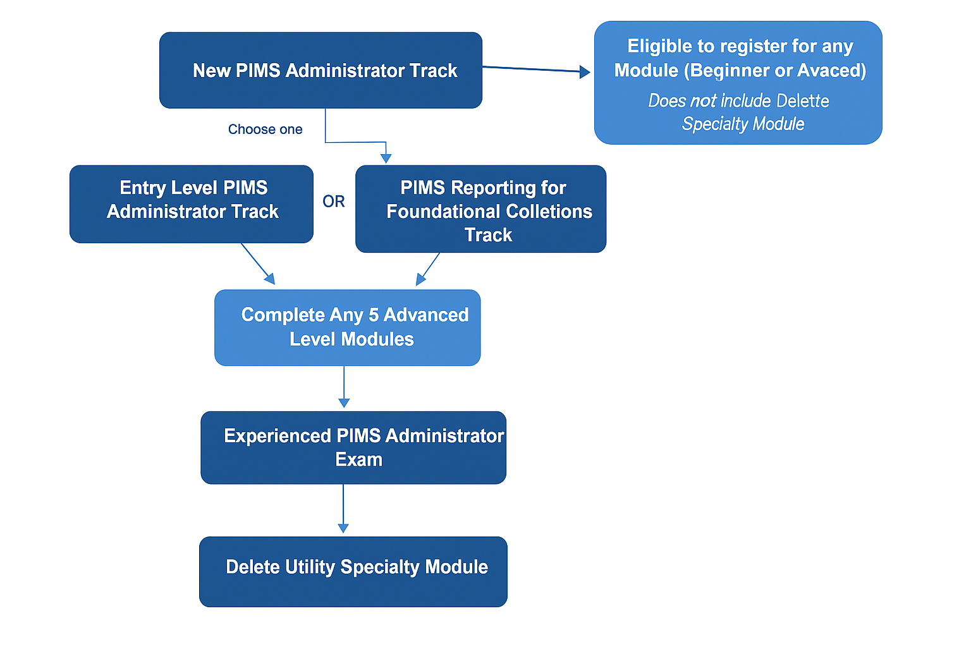

Curriculum Prerequisites

New PIMS Administrators
Definition: Individuals are typically considered to be a New PIMS Administrator if they have less than (<) 3 years of experience in the PIMS profession.
A New PIMS Administrator is new to the world of PIMS. There are many facets to PIMS reporting and it requires dedication and practice to learn and become confident in your role. This does not happen quickly.
For the Data Quality Curriculum, any person that wishes to register for DQC instruction and has not previously participated or completed any Tracks must begin with the New PIMS Administrator Track.
Exception: Special Education, LEA Administrator and Building Level Administrator Tracks are all considered “stand alone” Tracks and do not require prior completion of the New PIMS Administrator Training.

Entry Level PIMS Administrators
Definition: Individuals are typically considered to be an Entry Level PIMS Administrator if they have 3-5 years of experience in the PIMS profession.
An Entry Level PIMS Administrator is someone who has been around for more than 3 years and has learned the basics. They navigated through challenges during C1 and other collections; however, things are beginning to make sense.
For the Data Quality Curriculum, individuals must first complete the New PIMS Administrator Track and can then move on to Entry Level status by choosing to complete the following:
- Entry Level PIMS Administrator Track, or
- PIMS Reporting for Foundational Collections Track (recommended), or
- both.

Experienced PIMS Administrators
Definition: An Experienced Level PIMS Administrator is typically someone that has 5 or more years of experience in the PIMS profession.
For the Data Quality Curriculum, individuals must meet the requirements outlined to reach Entry Level PIMS Administrator status before becoming an Experienced PIMS Administrator.
Individuals that have successfully attained Entry Level PIMS Administrator status must complete the following two requirements to demonstrate a higher level of knowledge and understanding of the PIMS process:
- Successfully complete any five (5) DQC Advanced-level Modules THEN
- Successfully complete and pass the Experienced PIMS Administrator Exam

Delete Utility Specialty Module
An individual is not eligible to register for the Delete Utility Specialty Module until they have successfully completed the requirements to reach Experienced PIMS Administrator status.

Modules
Any individual is eligible to register for any instructional Module provided in the Data Quality Curriculum after completing and receiving a passing grade for ANY PIMS Administrator DQC Track (excludes Special Education).
Modules are divided into two categories: Beginner and Advanced. While anyone who has successfully completed any Track can register for any Module, it is important to note that only Modules that are designated as Advanced level count toward the requirement to take the Experienced PIMS Administrator Exam.

ACT 45/ ACT 48 Credits
Upon successful completion of Curriculum Tracks and Modules, individuals will earn a PDE certificate and Act 45 or Act 48 credits based on the content offered. Both Act 45 and Act 48 credits will be issued by the designated Intermediate Unit.
The following Tracks offer Act 45 credits (all other Tracks and Modules offer Act 48 only):
- LEA Administrator Track
- Building Level Administrator Track

Data Quality Curriculum Course Catalog

General Requirements
To receive full credit for Act 45 or 48 and a certificate of completion, individuals registered for any DQC Track or Module must complete each assignment, quiz or activity AND attain a 90% overall grade for knowledge test components.
Individuals that do not complete all materials for the Track/Module but still achieve a passing grade (90%) on knowledge assessment will NOT receive credit for completing the course and will NOT attain access to the next level of PIMS Administrator status.

Certificate of Completion
Individuals that register for and complete the requirements to pass any DQC Track/Module (90% overall knowledge test grade and all items completed) will receive a link to print a physical Certificate of Completion on the Moodle site once all coursework has been graded and verified.

Data Quality Curriculum Tracks

New PIMS Administrator Track

Prerequisite
None: Starting point for anyone that has never completed and passed a DQC Track or Module.
Course Description
The DQC New PIMS Administrator Track is designed for those individuals with little experience submitting PIMS data. This Track will help gain familiarity with the resources available to PIMS Administrators as well as an understanding of the basic process and skills needed to submit high quality data to PIMS.

Entry Level PIMS Administrator Track

Prerequisite
New PIMS Administrator Track
Course Description
The DQC Entry Level PIMS Administrator Track will test knowledge of PIMS reporting resources and will reinforce the understanding of the PIMS process, terminology and accuracy review measures.

PIMS Reporting for Foundational Collections Track

Prerequisite
New PIMS Administrator Track
Course Description
The PIMS Reporting for Foundational Collections Track will explore the primary collections that make are prerequisites for all other reporting colelctions. It will provide a detailed look at the October Student, October Staff, and Graduation Dropout Cohort collections that provide foundational data used for PIMS reporting throughout the school year.

Special Education Track

Prerequisite
None
Course Description
The Special Education Track has been created especially for LEA staff members that work with, are impacted by, or have an impact on data submitted for special education reporting. This Track will increase participants’ understanding of data reporting as it relates to compliance, local requirements and funding that is integral to special education student achievement and support.
*This Track does not qualify for Module access.

LEA Administrator Track

Prerequisite
None
Course Description
The LEA Administrator Track has been created especially for Local Education Agency (LEA) principals, building administrators, superintendents or those who approve reports related to data accountability and funding. This track focuses on the role that LEA leadership plays in data governance. Participants will develop or expand upon a data governance plan which exhibits the best practices of data analysis, interpretation and application to ensure increased student achievement and maintain regulation compliance.
*This Track qualifies for Act 45 credit.
*This Track does not qualify for Module access.

Building Level Administrator Track

Prerequisite
None
Course Description
The Building Level Administrator Track has been created especially for building level administrators who review reports related to data accountability. This track focuses on the role building level leadership plays in data governance. Participants will develop or expand upon a building-focused data plan which exhibits the best practices of data analysis, interpretation and application to ensure increased student achievement through maintaining data accuracy.
*This Track qualifies for Act 45 credit.
*This Track does not qualify for Module access.

Data Quality Curriculum Modules

Beginner Level Modules

Act 13 Educator Effectiveness/PVAAS

Prerequisite
Any completed and passed PIMS Administrator Track
Course Description
The Act 13 Educator Effectiveness/PVAAS Module will provide participants with a general overview of how data impacts educator assessment through the Educator Effectiveness system. The term "educator" includes teachers, all professional and temporary professional employees, education specialists, and school administrators/principals.
*This Module does not qualify for Experienced PIMS Administrator status.

Data Governance

Prerequisite
Any completed and passed PIMS Administrator Track
Course Description
The Data Governance Module will review the resources available and will provide an understanding of how to begin implementing consistent and proper handling of data within your LEA.
*This Module does not qualify for Experienced PIMS Administrator status.

Data Literacy

Prerequisite
Any completed and passed PIMS Administrator Track
Course Description
The Data Literacy Module will help users to understand the many areas that make up data literacy for state reporting. Participants will gain a knowledge base that enables them to transform raw data into accurate, compliant information for state reporting.
*This Module does not qualify for Experienced PIMS Administrator status.

Data Quality Engine

Prerequisite
Any completed and passed PIMS Administrator Track
Course Description
The Data Quality Engine (DQE) Module will reinforce current knowledge of the DQE procedures. Upon completion of this module participants will have a better understanding of technical and practical PIMS data submission procedures.
*This Module does not qualify for Experienced PIMS Administrator status.

EdNA Basics

Prerequisite
Any completed and passed PIMS Administrator Track
Course Description
The EdNA Basics Module will provide an overview of the EdNA resource that is vital for PIMS reporting. EdNA (Education Names and Addresses) can be used to find name, address, administrator, and related information about the educational entities that PDE serves. These entities include school districts and their schools, intermediate units, career and technical centers, charter schools, nonpublic and private schools, higher education institutions, and many more.
*This Module does not qualify for Experienced PIMS Administrator status.

EdNA Reports

Prerequisite
Any completed and passed PIMS Administrator Track
Course Description
The EdNA Reports Module will provide an overview of how to run and utilize the reports available in the EdNA system. EdNA can be used to find name, address, administrator, and related information about the educational entities that PDE serves. These entities include school districts and their schools, intermediate units, career and technical centers, charter schools, nonpublic and private schools, higher education institutions, and many more.
*This Module does not qualify for Experienced PIMS Administrator status.

EL Reporting

Prerequisite
Any completed and passed PIMS Administrator Track
Course Description
The EL Reporting Module will provide an overview of the data fields that impact PIMS reporting for English Learner (EL) students and will review the requirements for each EL-related PIMS reporting collection.
*This Module does not qualify for Experienced PIMS Administrator status.

Excel for PIMS

Prerequisite
Any completed and passed PIMS Administrator Track
Course Description
The Excel for PIMS Module will provide hands-on exercises and examples that will demonstrate useful Excel tools that will simplify the process of reviewing and manipulating data for PIMS reporting.
*This Module does not qualify for Experienced PIMS Administrator status.

Internal Snapshots

Prerequisite
Any completed and passed PIMS Administrator Track
Course Description
The objective of the Internal Snapshot Module is to reinforce current knowledge. The purpose of an internal snapshot is to capture records from each LEA at a specific point in time. Internal snapshots will occur various times throughout the school year and contain records for students who have an active enrollment record for the internal snapshot date. Upon completion of this module participants will reinforce knowledge of technical and practical procedures.
*This Module does not qualify for Experienced PIMS Administrator status.

PAsecureID

Prerequisite
Any completed and passed PIMS Administrator Track
Course Description
PAsecureID is the lynch pin to the Pennsylvania Information Management System (PIMS). The PAsecureID Module will guide you on how to obtain a PAsecureID for a student, while familiarizing you with the functions, resources, common problems and demographic issues associated with PAsecureID.
*This Module does not qualify for Experienced PIMS Administrator status.

PIMS Upload Simulation

Prerequisite
Any completed and passed PIMS Administrator Track
Course Description
The PIMS Upload Simulation Module takes a step-by-step approach to understanding the PIMS upload process. This Module will address the File Manager and Batch Manager stages and will provide guidance for reviewing, interpreting and correcting the errors frequently encountered at each phase.
*This Module does not qualify for Experienced PIMS Administrator status.

Advanced Level Modules

Accountability

Prerequisite
Any completed and passed PIMS Administrator Track
Course Description
The Accountability Module will review the resources available on the PDE website and will provide an understanding of how to interpret and effectively use the Attribution Map.
*This Module does qualify for Experienced PIMS Administrator status.

Assessment

Prerequisite
Any completed and passed PIMS Administrator Track
Course Description
The Assessment Module will provide information on the Assessment Data Set How To guide, vital PIMS reports associated with Assessment, and the PIMS Data Collection calendar. Participants will gain an understanding of Internal Snapshots and proper measures for review and preparation to ensure more accurate Assessment reporting.
*This Module does qualify for Experienced PIMS Administrator status.

Career and Technology Education

Prerequisite
Any completed and passed PIMS Administrator Track
Course Description
The objective of the Career and Technology Education (CTE) Module is to reinforce current knowledge of CTE procedures while providing an opportunity to gain endorsement for PDE certification. Participants will familiarize themselves with current terminology as well as technical reporting procedures.
*This Module does qualify for Experienced PIMS Administrator status.

Career Standards Benchmark

Prerequisite
Any completed and passed PIMS Administrator Track
Course Description
The Career Standards Benchmark data set is used to track students’ attainment of the benchmarks in grade 5, 8, and 11. This collection directly impacts the calculation of the Career Standards Benchmark indicator on the Future Ready PA Index and is used in conjunction with other measures to identify schools in need of support.
The Career Standards Benchmark Module will provide an overview of the data and the reports that will help validate that data in PIMS and will also explain how it translates to the Future Ready PA Index.
*This Module does qualify for Experienced PIMS Administrator status.

Charter School Updates

Prerequisite
Any completed and passed PIMS Administrator Track
Course Description
The Future Ready Comprehensive Planning Portal (FRCPP) was​ created to provide a consistent planning framework and collection tool for all Pennsylvania local education agencies (school districts, charter schools, area vocational schools/career and technical centers, Intermediate Units) and schools. This new model provides flexibility in the planning process based on individual community needs, is grounded in an outcomes-based approach focused on student achievement and encourages schools and districts to more effectively and efficiently plan and lead innovative school improvement practices. The core concepts are based on a simplistic logic model, one that any local education agency or school can effectively use for developing cohesive long-term goals and action plans, monitoring yearly progress, and providing transparency in communication with school personnel, state officials, parents and community.
This Module will provide details for updating Charter School Administrator roles in the FRCPP system.
*This Module does qualify for Experienced PIMS Administrator status.
*Only open to enrollment for active Charter Schools and/or IUs that support Charter School data submissions.

Child Accounting

Prerequisite
Any completed and passed PIMS Administrator Track
Course Description
The Child Accounting Module will reinforce current knowledge of child accounting procedures. Participants will gain knowledge in Child Accounting terminology, and procedures.
*This Module does qualify for Experienced PIMS Administrator status.

Course/Appropriately Certified

Prerequisite
Any completed and passed PIMS Administrator Track
Course Description
The PIMS Course/Instructor data set has been included in PIMS since its inception in the 2007-08 school year. The data set contains lists of courses and the students and teachers related to those courses. The Course/Appropriately Certified Module provides an overview of the common errors and reports that are essential for validation of course data that determines instructor appropriately certified status.
*This Module does qualify for Experienced PIMS Administrator status.

FRCPP- Administrator Changes

Prerequisite
Any completed and passed PIMS Administrator Track
Course Description
The FRCPP was​ created to provide a consistent planning framework and collection tool for all Pennsylvania local education agencies (school districts, charter schools, area vocational schools/career and technical centers, Intermediate Units) and schools. This new model provides flexibility in the planning process based on individual community needs, is grounded in an outcomes-based approach focused on student achievement and encourages schools and districts to more effectively and efficiently plan and lead innovative school improvement practices. The core concepts are based on a simplistic logic model, one that any local education agency or school can effectively use for developing cohesive long-term goals and action plans, monitoring yearly progress, and providing transparency in communication with school personnel, state officials, parents and community.
The FRCPP- Administrator Changes Module will review the process for ensuring that the correct and most up-to-date personnel have access to FRCPP to review and approve data.
*This Module does qualify for Experienced PIMS Administrator status.

FRCPP- School Reconfiguration Changes

Prerequisite
Any completed and passed PIMS Administrator Track
Course Description
The FRCPP was​ created to provide a consistent planning framework and collection tool for all Pennsylvania local education agencies (school districts, charter schools, area vocational schools/career and technical centers, Intermediate Units) and schools. This new model provides flexibility in the planning process based on individual community needs, is grounded in an outcomes-based approach focused on student achievement and encourages schools and districts to more effectively and efficiently plan and lead innovative school improvement practices. The core concepts are based on a simplistic logic model, one that any local education agency or school can effectively use for developing cohesive long-term goals and action plans, monitoring yearly progress, and providing transparency in communication with school personnel, state officials, parents and community.
The FRCPP- School Reconfiguration Changes Module will review the process for updating school information to prevent errors in PIMS reporting.
*This Module does qualify for Experienced PIMS Administrator status.

Future Ready Overview

Prerequisite
Any completed and passed PIMS Administrator Track
Course Description
The Future Ready PA Index is a collection of school progress measures related to school and student success. The Index depends heavily on data reported by each LEA. This module explains the Index and walks the user through a series of resources that explains the data sources used. Users successfully completing this module will be familiar with the various data sources that are used in the Index and will be able to either answer specific questions about the various measures displayed in the Index, or at least, know where to look for those answers.
*This Module does qualify for Experienced PIMS Administrator status.

Non-CTE ICN/WBL (Industry Credential)

Prerequisite
Any completed and passed PIMS Administrator Track
Course Description
The Industry-Recognized Credentials and Work-Based Learning Experiences for Non-CTE Students (Non-CTE ICN/WBL) data set is used to document student’s credentials earned and work-based learning experiences for students outside the scope of an approved Career and Technical Education (CTE) program. This collection directly impacts the calculation of the Industry-Based Learning indicator on the Future Ready PA Index.
This Module will review the resources and data used to calculate the Industry-Based Learning Indicator on the Future Ready PA Index.
*This Module does qualify for Experienced PIMS Administrator status.

School Services- Ward of State

Prerequisite
Any completed and passed PIMS Administrator Track
Course Description
The School Services - Ward of State Module will review the definition of and the process for determining a student’s Ward of State (WOS) status. This Module will also address proper documentation and communication requirements associated with WOS determination.
*This Module does qualify for Experienced PIMS Administrator status.

Experienced PIMS Administrator Exam

Prerequisite
Complete and pass any five (5) Advanced Level DQC Modules
Course Description
The Experienced PIMS Administrator Exam is not an instructional component of the DQC. Individuals that have progressed through the outlined stages of PIMS knowledge development (New PIMS Admin, Entry Level PIMS Admin) will demonstrate their advanced knowledge of PIMS-related processes and collections addressed in the Data Quality Curriculum. This is a high-level exam that provides no resources. It is assumed that individuals that feel they are “Experienced” will demonstrate both an understanding of collection content and the resources required to research guidance independently.

Delete Utility Specialty Module

Prerequisite
Complete and pass the Experienced PIMS Administrator Exam
Course Description
The Delete Utility Specialty Module provides an overview of the PIMS Delete Utility. This special tool grants the unique ability to Delete limited templates, at the discretion of the PIMS Administrator, without the need for submitting a request to PDE.

*The Delete utility does not provide delete capability for all templates or all collections!

